IDEATION PHASE BRAINSTORM & IDEA PRIORITIZATION

|  |  |
| --- | --- |
| DATE | 10 OCT 2022 |
| TEAM ID | PNT2022TMID07468 |
| PROJECT NAME | Estimate the Crop yield using Data Analytics |
| MAXIMUM MARK | 4 Marks |

Brainstorm & Idea Prioritization:

Step 1: Team Gathering, Collaboration and Select the Problem Statement

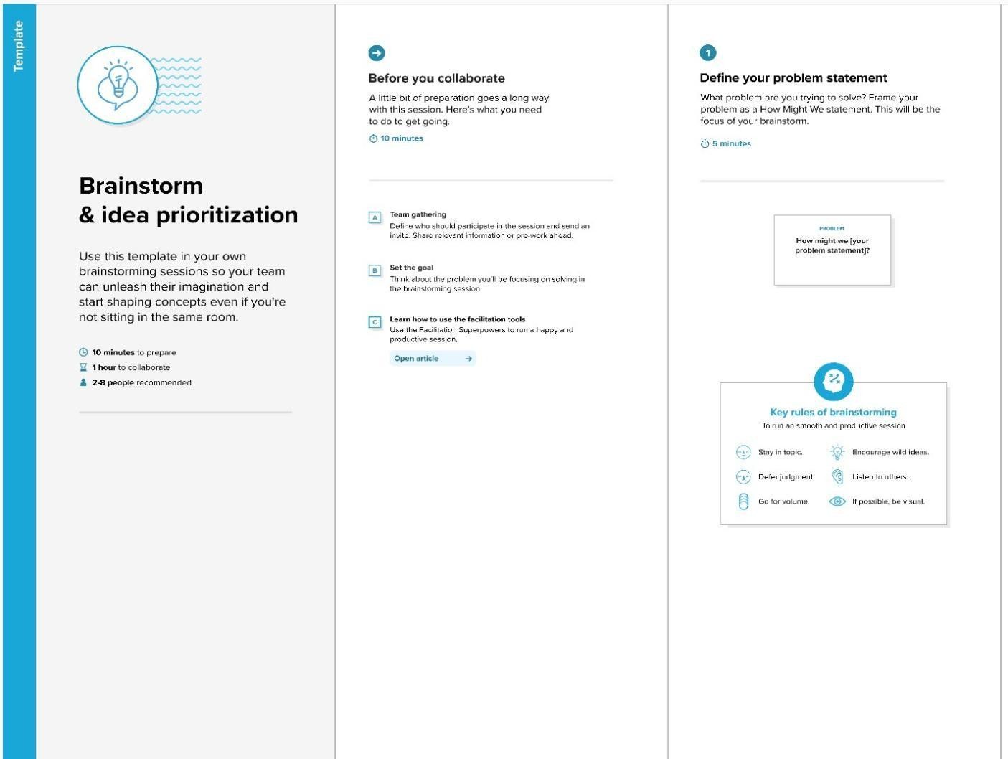

Step 2: Brainstorm, Idea listing and Grouping

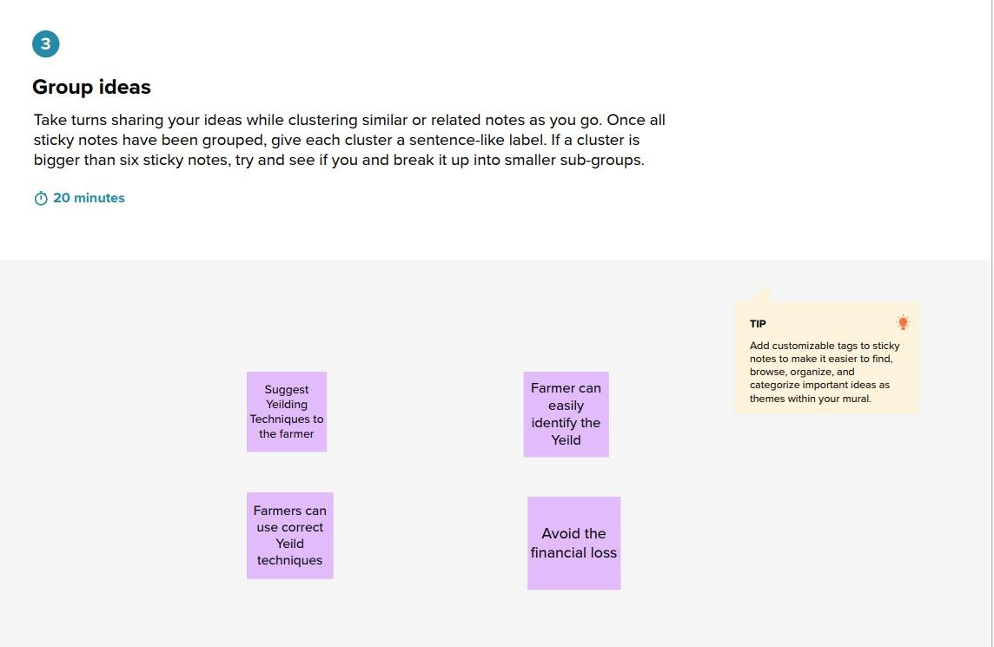

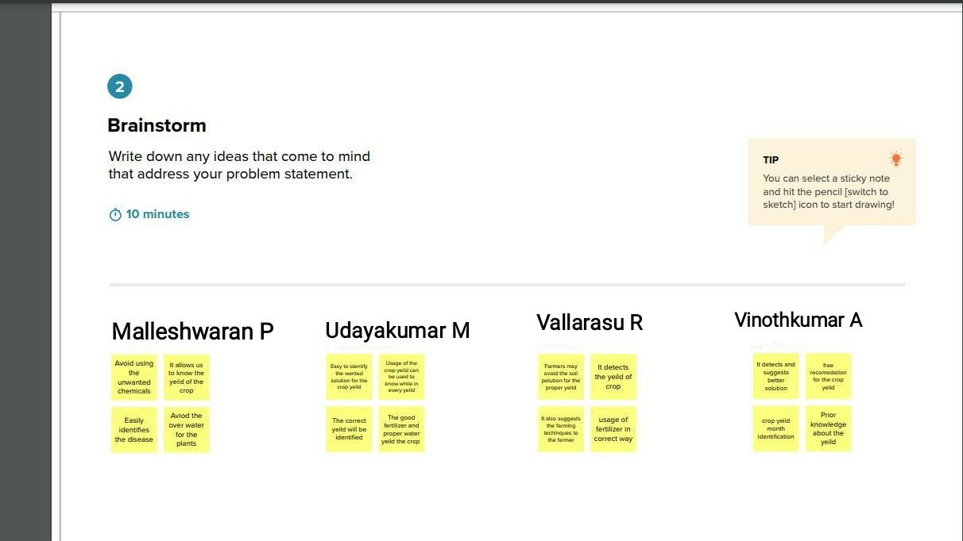

Step 3: Idea Prioritization

